- To retrieve all the products, make a Get REQUEST to the server.
GET: /api/products
RESPONSE: 200 OK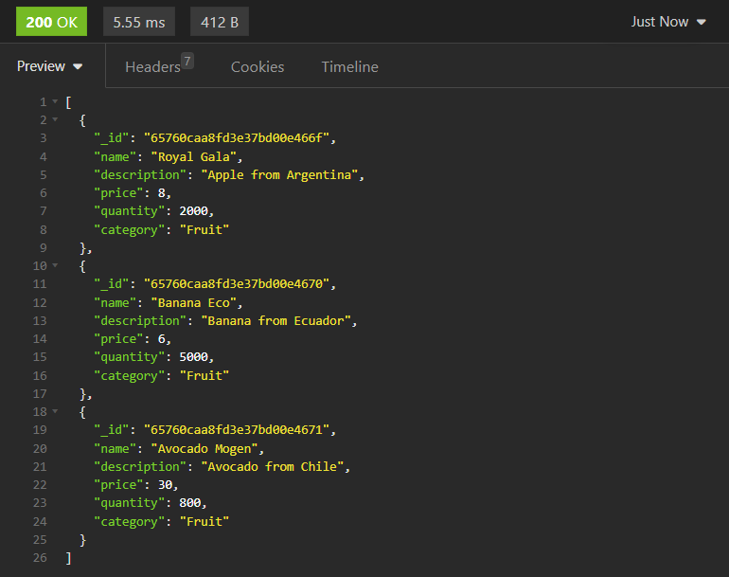

- To retrieve a specific product by ID, make a GET REQUEST to the server.
GET: /api/products/:id
RESPONSE: 200 OK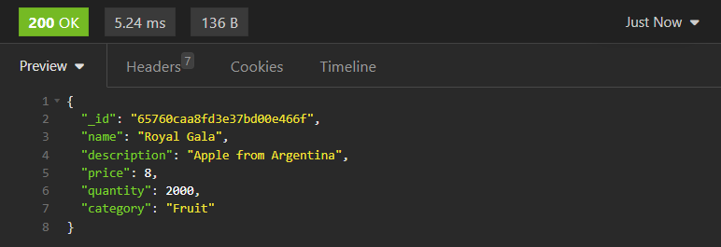

If the product cannot be found or the ID is incorrect when retrieving a specific product by ID:
RESPONSE: 404 Not Found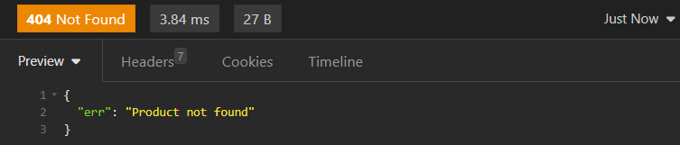

- To create a new product, make a POST REQUEST to the server.
POST: /api/products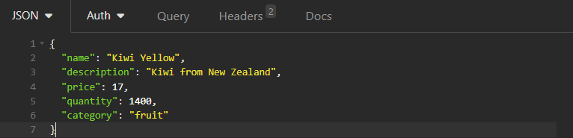
RESPONSE: 201 Created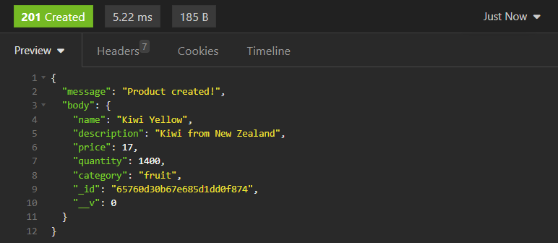
Doublecheck with GET all products to make sure the new product is added: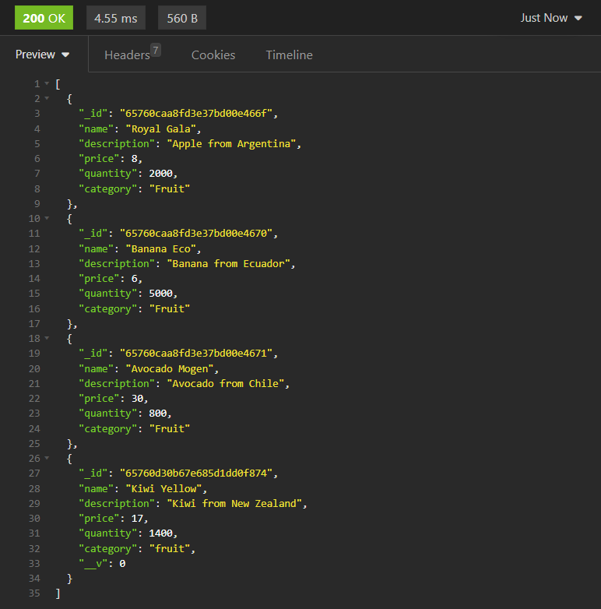

If any of the required property is missing when creating a new product with POST REQUEST: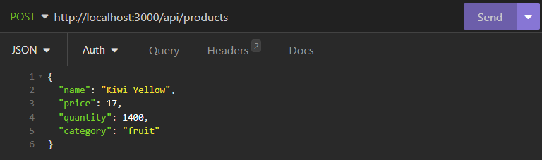
RESPONSE: 400 Bad Request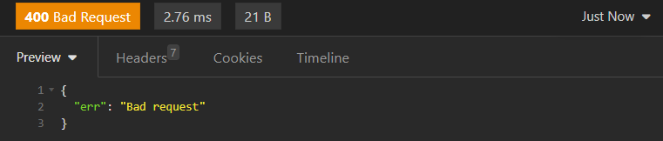

- To update a specific product by ID, make a PUT REQUEST to the server.
PUT: /api/products/:id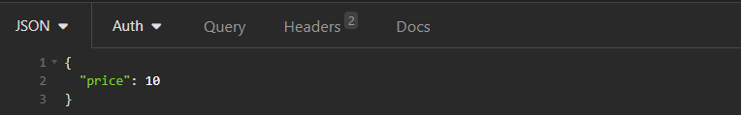
RESPONSE: 200 OK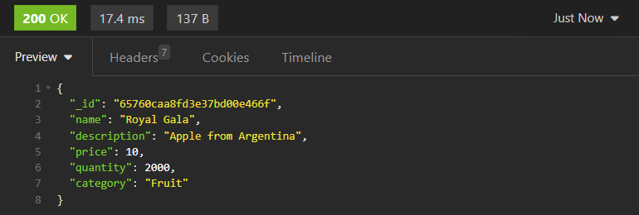

If update non-existed property when updating a specific product with PUT REQUEST: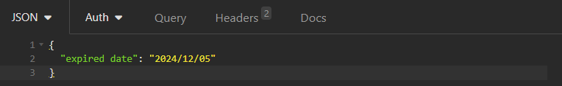
RESPONSE: 400 Bad Request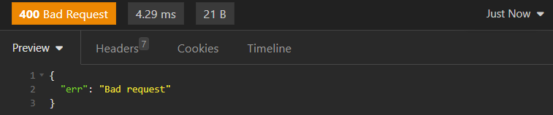

If update property to the non-existed product when updating a specific product with PUT REQUEST:
RESPONSE: 404 Not Found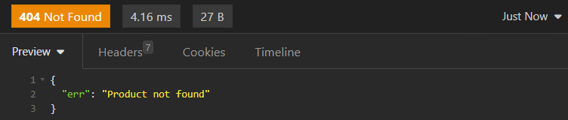

- To delete a product by ID, make a DELETE REQUEST to the server.
DELETE: /api/products/:id
RESPONSE: 200 OK
Doublecheck with GET all products to make sure the product is deleted: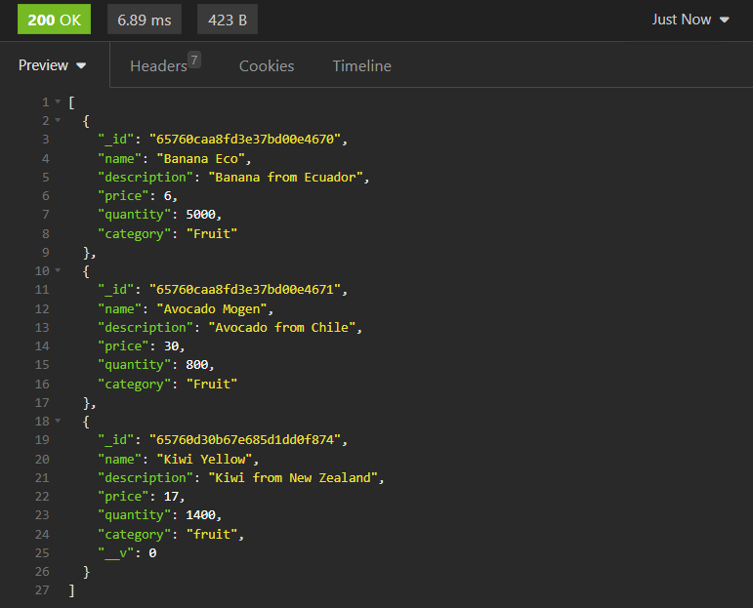

If the product cannot be found or the ID is incorrect when deleting a specific product by ID:
RESPONSE: 404 Not Found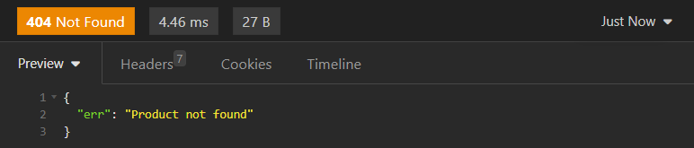

- To delete all the products, make a DELETE REQUEST to the server.
DELETE: /api/products
RESPONSE: 200 OK
Doublecheck with GET all products to make sure all the products are deleted:

- To retrieve a product whose name contains specified keyword, make a GET REQUEST to the server.
GET: /api/product?name=an
RESPONSE: 200 OK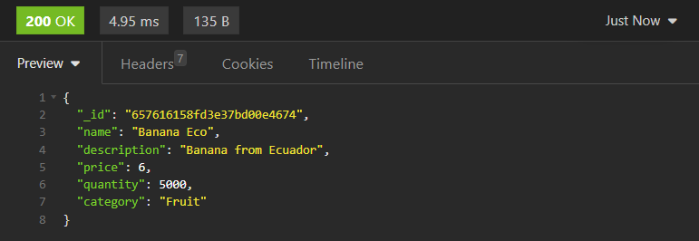

If the product cannot be found or the name is incorrect when retrieving a specific product whose name contains specified keyword:
RESPONSE: 404 Not Found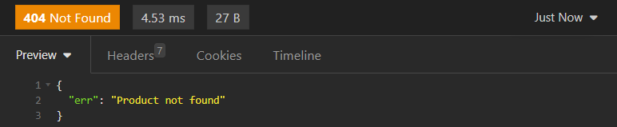

If the search param is incorrect when retrieving a specific product whose name contains specified keyword:
RESPONSE: 400 Bad Request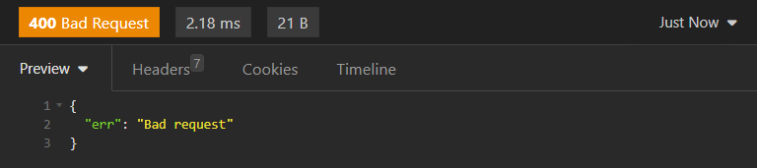

- To send back HTML with all products in a table with all information about the product, make a GET REQUEST to the server.
GET: /
RESPONSE: 200 OK with HTML